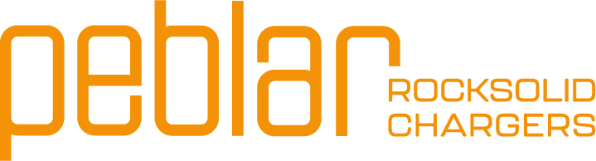

Release notes
Firmware release 1.9.0
2026 Q1
Introduction
Dear valued customer and partner of Peblar,
We are pleased to share this document containing essential information and instructions regarding the firmware update 1.9.0 for our chargers. This release includes new features and fixes to enhance functionality, usability, and performance. We encourage you to share this valuable information with relevant stakeholders in your organization.
New features in firmware update 1.9.0
The latest firmware update introduces several new features designed to enhance charger functionality and simplify user operations. Below are the highlights:

- Support of Xemex Smart Connect: Peblar supports the Xemex Smart Connect dongle, so that the P1 or TIC meter can be read out hardwired ensuring robust measurements.
- Manual fill-in IP address for P1 dongles: The installer can manually fill in the IP address of the P1 dongle if it cannot be found automatically.
- Adjustable Charge Point ID: During commissioning, the Charge Point ID can be adjusted to successfully connect to the CPO backoffice if needed.
- Support of P-Card using Calypso protocol: The charger now supports the P-Card using the Calypso protocol, ensuring more compatibility for charging passes.
- Support of selected Eastron meters: The Peblar now supports more Eastron meters for more choice for the installer.
- Authorization via local REST API: With this update, you do not need to scan your RFID card when starting a charging session using the local REST API.
- Support ISO15118-2 (Business Socket only)
- Other minor improvements

Support Xemex Smart Connect
The Xemex Smart Connect is a new product on the market that can read out the P1 port or TIC port and connect to either the local network via ethernet or WiFi or the Peblar directly using an ethernet cable. More information can be found on https://www.xemex.eu/product/smart-connect-p1/

Commissioning

Select the Xemex Smart Connect as measurement source in commissioning at the ‘dynamic load balancing’, ‘solar charging’* or ‘household limit’* step, and it will try to automatically connect to this source.
*Note that solar charging and household limit are only supported with P1 interface, not via TIC

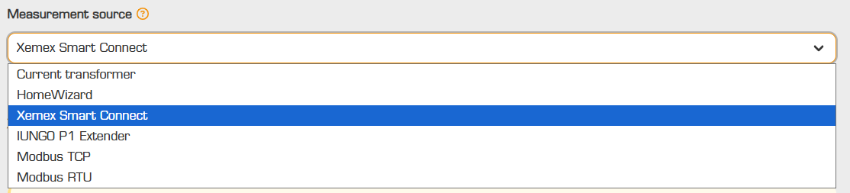

OCPP parameters
- BopSource/SolarChargingSource/UserDefinedHouseholdPowerLimitSource: A new option is added to select the measurement source: “xemex-smart-connect”
Manual fill-in IP for P1 dongles
Sometimes, the Peblar cannot find the P1 dongle in the local network. To increase the success rate for installation and commissioning, we introduce the possibility to manually fill in the IP address of the dongle connected to the local network. In this way, there is a higher probability that the dongle will be found and can be used for smart charging purposes.

Commissioning

Select ‘Manual’ when selecting a dongle as measurement source (for example the HomeWizard). Here, you can fill in the IP address of the dongle. This IP address can either be found in the application of the dongle (if applicable) or by logging into the router and search for the IP address of the device.

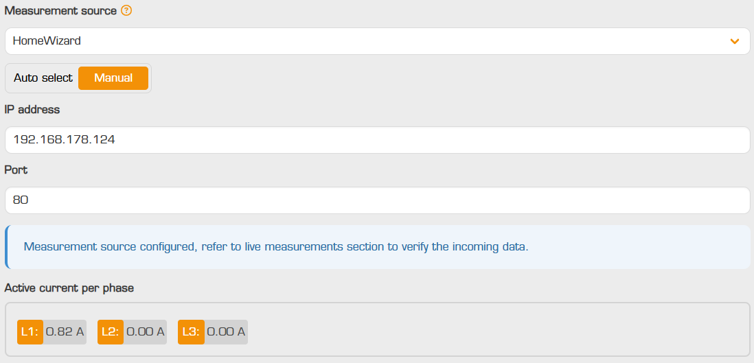
Adjustable Charge Point ID
The Charge Point ID of the charger (which is the name of the charger at which it communicates to the CPO backoffice) can be adjusted in the commissioning interface. This is beneficial for installers that have been given instructions to install a Peblar charger with an ID given by the CPO.

Commissioning

Open the advanced settings after selecting a CPO backoffice from the dropdown menu. There, a new adjustable field has been added called ‘Custom Charge Point ID’. You can fill in the preferred ID.
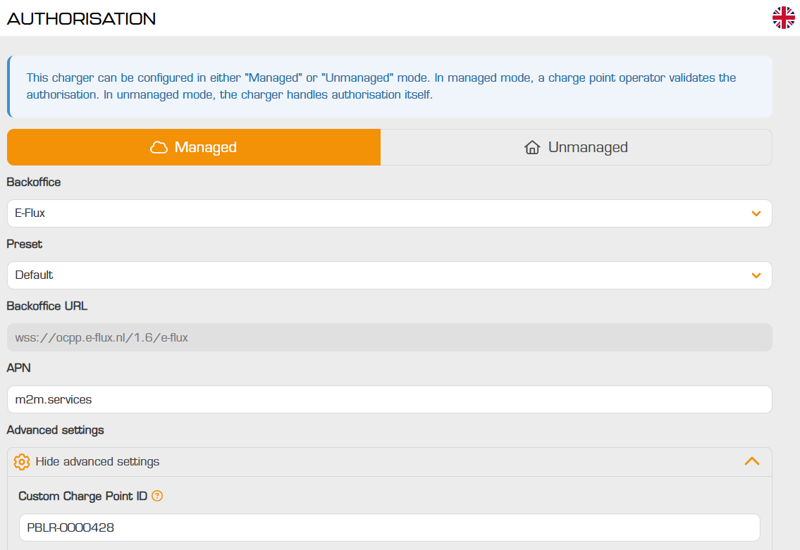

Adjust the identifier to your liking and select “save”. You can now continue to commission the charger. Once the commissioning has been completed, the charger will connect to the CPO backoffice using the newly given Charge Point ID.

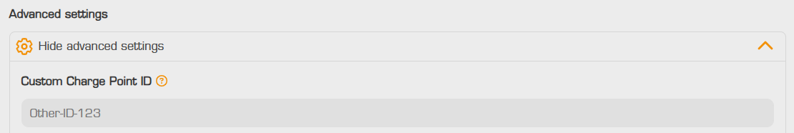

OCPP parameters
- CustomCustomerId: This key can be used to remotely adjust the Charge Point ID of the charger.

Notes:

- If an incorrect identifier has been given, the charger might not connect to the CPO backoffice. Please ensure that the newly given identifier is correct!
Support of P-Card using Calypso protocol
The chargers now support the P-Card using the Calypso protocol. This setting has been turned on for our Pebalr off-the-shelf chargers. This functionality can be activated via the CPO backoffice, if desired.
Please reach out to your account team if you use the Calypso protocol for other charging passes than the P-Card, so that it can be integrated into our products as well.

OCPP parameters
- RfidPCardsAllowed: Use this parameter to enable or disable reading out the P-Card.
Support of selected Eastron meters
The charger now supports additional Eastron meter variants: SDM630MCT-MOD-MID, SDM220 and SDM230. Visit our integrations website to see the complete list of supported Modbus meters: https://peblar.com/integrations

OCPP parameters
- BopSourceParameters/SolarChargingSourceParameters/UserDefinedHouseholdPowerLimitSourceParameters: When selecting “modbustcp” as source, the “sdm630mct” can be selected as well, representing the Eastron SDM630MCT-MOD-MID meter. When selecting “modbusrtu” as source, “sdm220”, “sdm230” and “sdm630mct” can be selected, representing the Eastron SDM220, SDM230 and SDM630MCT-MOD-MID meters respectively.
- Please read the SPD with OCPP configuration parameters provided with the release notes for more information about the configuration of OCPP parameters for Modbus meters.

ISO 15118-2:
- Support for Business Socket models

THE INFORMATION IN THIS DOCUMENT IS FOR INFORMATIVE PURPOSES ONLY, IS PROVIDED AS IS, AND MAY BE SUBJECTED TO CHANGE WITHOUT NOTICE.
While reasonable efforts are undertaken to ensure that this information is correct, we cannot guarantee that the information provided is completely free from inaccuracies. We are not liable for possible inaccuracies or completeness of information.
Reach out to the Peblar account managers for inquiries.

© 2026 Peblar by Prodrive Technologies. All rights reserved.

peblar.com | February 2026

